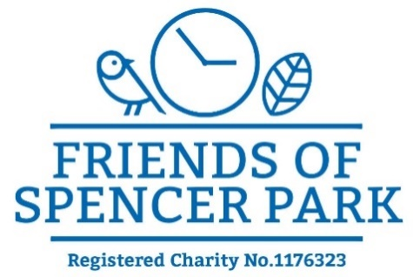

Minutes of the Committee Meeting held on 2nd October 2023

Present: Carol Bayliss, Jane Donovan, Zilpha Reed, Tim Brooke, Peter Elias, Liz Bayton, Helen Spence, Ken Taylor.

- Welcome by the chair Helen Spence

- Apologies: Debbie Riorden, John Gallagher, Anthony Godber, Pat Ryan, Dave Chater, Karen Berry

- AGM The Committee declared they were not quorate at this time to hold Annual General Meeting. It was agreed to hold the meeting at a later date.
- Minutes of previous meeting Minutes of the Committee Meeting of the 4th September 2023 were approved.

- Matters arising Actions pending from previous meeting included
signs to be purchased for Baby Changing facilities, Community Orchard, Meeting between Ken and Dave Lewis regarding hot water, shutters and previous roof leaks in the pavilion. Designs for new gate to flat green approved and agreement to go ahead was confirmed.

Helen Spence reported back to committee on the apparent success of ‘Nature Makers’ and how the ethos of the project reflects the values we are trying to promote in the park. It was agreed that the sessions should continue until Christmas when the project will be evaluated and renegotiated. No further charge will be made, and the £20 so far given will be counted as a donation.

- Events for October Carol talked the committee through the October Activities at the café and made an urgent request for as many cakes as possible for World Smile Days. She handed out a Pumpkin Parade Organisation sheet and committee members confirmed their help on the day. Members not at meeting will be mailed or spoken to, by Carol.

- Report from the Pavilion Committee Peter Elias gave the committee an update on the progress of the pavilion. He said we have £155,000 capital and £28,000 revenue for the first year. We have until the end of June 2024 to match fund. Crowd Funding has raised £4,570 and with Gift Aid is £5,600. He told us Crowd Funding is still ongoing and asked us to consider any organisations that might contribute. He is contacting people who signed the pavilion petition.
We still have to find £190,000. The Pavilion Committee have submitted a bid to the 29th May 1961 fund. Further bids to the Severn Trent Community Fund, Garfield Weston and Veolia are being written. There will be some ‘Contributing Third Party’ ie FoSP costs connected to these.
Before these bids are submitted planning position needs to be in place. There has been a delay in applying for planning permission from the Council which will affect the timetable for the submission of bids.
The Community Ownership Fund do consider match funding in kind as well as cash. It was decided to establish the value of the pavilion and find out if the COF would consider it as match funding.
A Royal Institute of Chartered Surveyors (RICS) surveyor, Phillip Reynolds, has surveyed the pavilion and will produce a written report of its value. It will cost about £700. He gave an informal valuation of £140 000-£190 000. The formal report will be sent to the COF for them to decide whether to accept it as match funding.
If the COF releases the money, then it is important to spend it before the June 2024 deadline. This will probably mean that the project has to be carried out in stages, and that contractors will need to be asked how the project could be organised on that basis.

- Report from the Trustees Planning permission for a garage was discussed and Ken informed us that the ground would need to be checked for a portable garage. He said in 8 weeks’ time we would know if we have planning permission for the pavilion and would go ahead with garage.

Ken reported the Trustee’s interest in knowing more clearly about income and expenditure in the café and at events. Jane discussed generating reports for the café with Zettle and Quickbooks and we discussed the setting up of a Company Ltd by Guarantee which would enable the café to have its own bank account, A Trustees meeting has been set up with Treasurer James Holdsworth on November 13th to make a decision about a Trading Arm and Jane was invited to attend.
- A.O.B – Jane told us Hannah Lant had enquired about using the pavilion for cookery lessons but at this time we are unable to help her due to Health and Safety regulations but Jane would remain in contact with her.
Anthony asked for his concern about the untidy nature of some of the notices on the park gates to be brought up. Some have been produced by the LTA without our knowledge.

- Date of next meeting November 6th 2023

